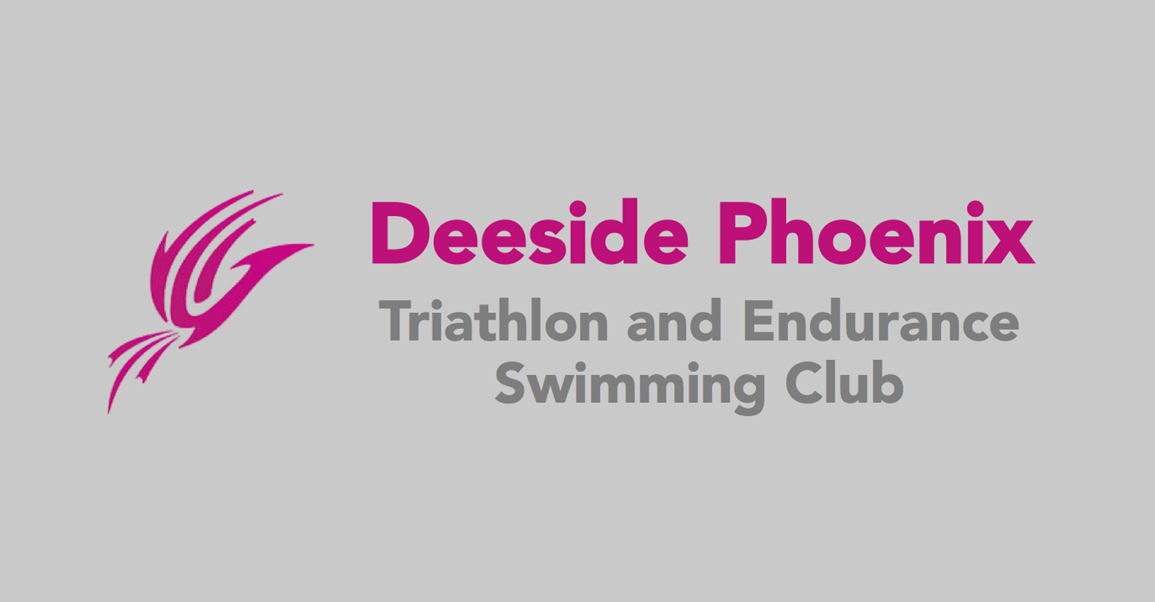

**Sport Scotland COVID Training:**

Catherine Bain: completed 1st October 2020

Brian Smith: completed 30th September 2020

Hilary Stewart: completed 29th September 2020